Megan LuRose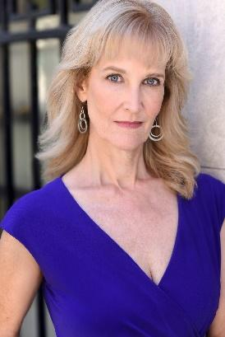

meganlurose@gmail.com

609-471-6435

www.meganlurose.com

**FILM**

HOT WHEELZ Principal Shayna Hayes

HOUSE OF BROTHERLY LOVE Day Player Max Kane

WAILING* Supporting Charlie Parker

THE PLACE WE’RE GOING Supporting Seamus Hayes

LAYERING Day Player Josh Coll

TIGHT Supporting Jillian Hartman

POLAROID Day Player Sam Elgart

DEFINITION Day Player Rubing Zhang

BEING THERE Day Player Dawson Keiser

THE CHECKERBOARD Supporting George Hawke

KILLING HER SOFTLY Day Player Shameka Jones/Christina Faith

CARPENTERS’ UNION/PSA Day Player Fluent Video/Adam Boyer

RETROGRADE VICTORY Supporting M. J. Walker

WANDERING EYES Supporting Michael Loftus

**REGIONAL THEATRE**

THE LOST BOOK OF NOSTRADAMUS Lady Chaucery Haunted Mansion, Cape May, New Jersey

SOUTH PACIFIC Ensemble Virginia Beach Musical Theatre

**MUSIC VIDEOS**

“BABY BLUE” by Greyscale Grieving Wife Jason Mizrahi

“FEATHERS” by PALM Medieval Woman Daniel Brennan  
“TURN AROUND” by The Vaughns Haunted Woman Steven MarcianoI

**TRAINING**

American Academy of Dramatic Arts Summer Program, Los Angeles

Acting with Mel Churcher (On-line) The Actors’ Studio, London

International School of Screen Acting-Intensive Summer Program, 3 Mills Studios, London

Walnut Street Theatre Philadelphia

Mike Lemon Film Acting Class King of Prussia, PA

Catapult Acting School-Intermediate (On-line) Atlanta

T. Schreiber Acting School, Acting for Commercials-Bill Coelis New York City

T. Schreiber Acting School, Shakespeare Scene Study-Page Clements New York City

**SPECIAL SKILLS:** Singing, Playing Guitar, Ballroom Dance, Southern Accent, Horseback Riding, Yoga, Dance-Ballet, Contemporary, Heels, Hip Hop, Conversational Spanish

**AWARD* IndieX Film Festival Outstanding Achievement Award Acting Ensemble**